

GYALPOZHING COLLEGE
OF
INFORMATION TECHNOLOGY

Mid-Term Assignment

Web Development Language-ITW101

ITW101

Submitted by:
Dorji Gyeltshen
12190049
Group A

Question1
Selector | Example | Example Description
The Universal Selector | * | Select all the elements
Type Selector | p,h1,.. | Select all the elements matches the specified in a list with the given values to determine the elements to which the css rules are applied.
Class Selector | <h1 class=”abc”> | Select all class elements that is defined with same names
The ID Selector | <h1 id=”abc”> | Select all id elements that is defined with same names
Child Selector | li>a{font-size:18px;} | It selects all ‘a’ elements which are child of ‘li’ elements
The Descendant Selector | Table b{font-size:18px;} | It selects all ‘b’ elements that are nested within the table element

Question2
Block Element | Inline-block Element
Inline elements are those who only take up as much width as is needed to display the contents of the element, thereby allowing other elements to be in line with the inline element. It can appears within sentences and do not have appear on a new line of their own.  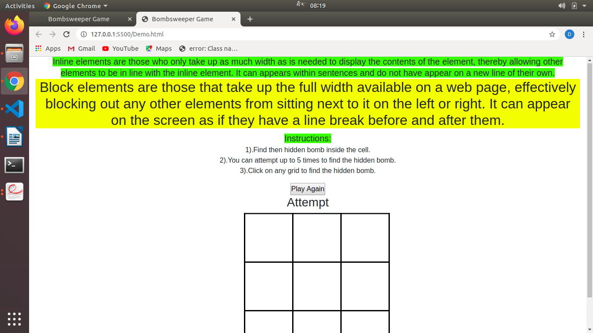 | Block elements are those that take up the full width available on a web page, effectively blocking out any other elements from sitting next to it on the left or right.  It can appear on the screen as if they have a line break before and after them.

THANK YOU

